FTP

* FileZilla FTP-client may be used to manage your WordPress site by uploading and downloading files and images
* FTP is a standard way to upload or download files between your local system and your web server, and FileZilla is a solid client for everyday FTP needs.

**Setting up the Options**

* You will need the following details regarding the FTP account on your server:

Your website ftp address (usually <ftp://example.com> if your URL is <http://example.com>)

Your ftp username

Your ftp password

* If you do not already have an FTP account on your server, use your cPanel or website administration tool to set one up -- it will have all the information needed
* Before connecting the FTP server, you should register it in the Site Manager. Once you register it, you just one click to connect the same server. To register the FTP server, follow below steps:

1. Click **File** > **Site Manager** from FileZilla main window.
2. Click **New Site** then name the new connection to what you want (example: My blog server).
3. Enter the ftp address for your website in Host box. Usually, if your website is [*http://www.example.com*](http://www.example.com), then the ftp address will be [*ftp://ftp.example.com*](ftp://ftp.example.com) or [*ftp://example.com*](ftp://example.com). **Note**: Do not put a / at the end unless specifically told to do so on your cPanel or by your host.
4. Leave the Port box blank. Default value 21 should be used. Only change these if your FTP account details explicitly indicate that you should.
5. Select **Normal** from Logon Type box
6. Enter the full username that you have been given in User box. It may be just a username, or it may look like an email address (but it isn't one). For instance, it would look similar to user or user@example.com.
7. Enter password. Remember that the password might be case sensitive.
8. Click OK.

[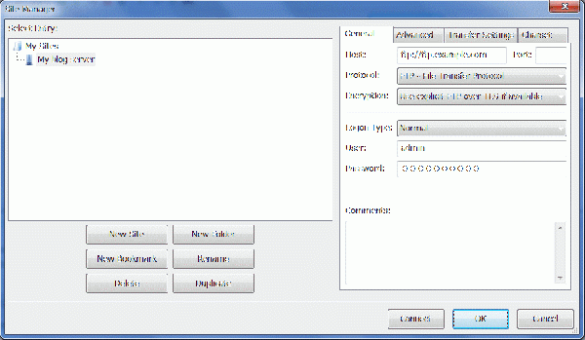](https://codex.wordpress.org/File:podz_filezilla_3.gif)

* Connecting

In the Toolbar of FileZilla main window, Select the down arrow of most left icon "Open the Site Manager", and select your FTP server from drop down list. Or, start Site Manager from File > Site Manager, select your FTP server and click 'Connect'.